**How to Effectively Plan Your Indie Game Project**

**Have a plan, then execute on it!**

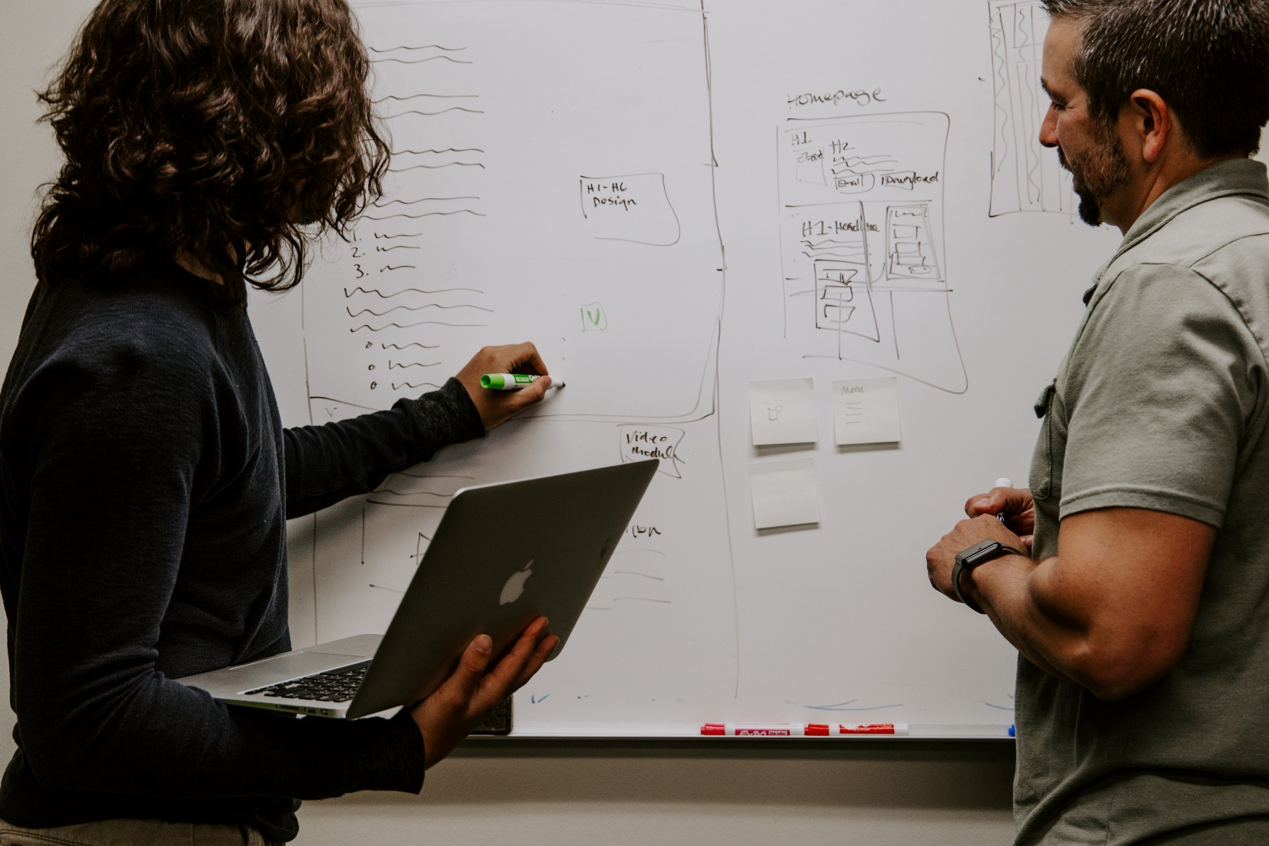

So, you’ve started kicking around some ideas for a game. Maybe you’ve just finished your last major project, or you are venturing out for the very first time. The pieces of a successful game float around in your brain, maybe on the back of a napkin, and you pitch it to a few of your friends. They love it! Emboldened with the feedback, it’s **time to deliver**.

If you are a developer, you probably want to break open Unreal, Unity, or GameMaker and start coding. If you are a creative, you may already have FL Studio or Adobe Photoshop open, crafting a leitmotif or concept art. These are great ways to start, but if you are heading up the project you need to approach the project from a different angle if you hope to complete it one day. Game Designers and Solo developers should already have a clue as to what I’l be discussing today.

It’s time to **plan** your indie game. I’ll discuss some tips on how to plan, what tools to use, and how the benefit you in the long run. No one enjoy planning, but trust me that with some organization and scaffolding around your endeavor, you are more guaranteed to succeed!

**Not AAA? Doesn’t matter. Plan your Path!**

You may think that the tools I’m going to suggest imply a grandiose scope. Don’t let your brain fool you! Planning is an important step for any successful project. Even in my [Why You Should Participate In A Game Jam](https://medium.com/@cjames1224/why-every-game-developer-should-take-part-in-game-jams-20a009bb24ea) article, I discuss a short planning stage before you begin. These projects are usually only active for a short span of days, but its still important to follow proper planning procedure. Organizational skills, working with others, brainstorming, and prototyping are all key components to saving your game from hitting the cutting room floor.

Keep in mind that I am discussing Indie Game Project planning. If you are writing a prototype, then sure these are nice-to-haves, but don’t let planning slow you down from proving your concept out. For more information on how to effectively prototype, check out [my article on the very same subject](https://medium.com/@cjames1224/game-and-software-prototyping-tips-101-3569b1efe828).

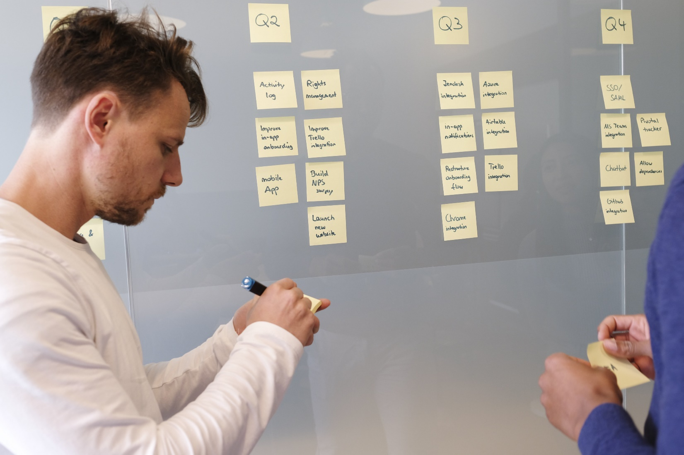

Trello provides and update to the classic “Kanban” style of organizing tasks. Photo by [airfocus](https://unsplash.com/@airfocus?utm_source=medium&utm_medium=referral) on [Unsplash](https://unsplash.com?utm_source=medium&utm_medium=referral)

Excellent tools for planning a project, with **free tier usage** as you go along include:

* [Trello](https://trello.com/)
* [Asana](https://asana.com/)
* [Slack](https://slack.com/intl/en-gb/)

**The Game Design Document**

Ah, the game design document. If you have ever worked on a game project with some planning behind it, or if you are a project manager by trade, the concept of a “design document” or “requirements document” should already be familiar to you. A game design document is your system of record, the ground truth for what you plan to deliver in your game. It holds all the design specifications for the game including

* Game Concept
* Game Mechanics
* Genre and Target Audience
* Game Flow (usually with diagrams)
* Story / Setting / Lore
* Level design and difficulty curve
* Thematic descriptions for art, music, user interface
* And much much more

Get acquainted with the game design document as soon as possible — this is a key piece of game design that you will be expected to know if you jump onboard a game development project.

Where can you find a template for a game design document, you ask? Here are some links that can get you started — you will soon find that there’s a perfectly formatted document out there for you!

* [Game Design Document — Benjamin “HeadClot”](https://docs.google.com/document/d/1axeeBWp683LPU8gCBQQqmquHMYHuG3uhNTN0LjSJBKk/mobilebasic)
* [University of North Carolina — GDD Template](http://www.cs.unc.edu/Courses/comp585-s15/DesignDocTemplate.pdf)
* [General Game Design Document](https://docs.google.com/document/d/1K8JKFPtEA08EutfHK3U_3wDDn2SWvJdpue0rmjiX4a0/edit)

**Production Schedule**

If you are solo developer, you may find the next two sections to be difficult to handle alone. But I still argue that they are important tools you should generate to guide your project.

A production schedule answers the question of, “So when will I be able to present ____?” And you can fill in the blank with whatever you are aiming to complete, be it an initial proof of concept, a demo release build, a convention or trade show build, a Steam release, etc. So in short this is a timeline of deliverables.

What will be worked on, and at what point will it be done? How long should it take to complete each task? How many people will be working on said task? Will they be able to multi-task and work on multiple components at once? These are all questions that your production schedule should answer.

A very **very general** list of tasks you will commonly see on production schedules includes

* Research Target Market and Competition
* Gather and scope out Assets
* Kick off Project
* Generate storyboards
* Complete Game Mechanic X
* Implement Y Feature
* Product a Vertical Slice of the game
* Unit and Validation Testing
* Product Gold release build

For those who are unaware, a Vertical Slice is one level, one scene, one vignette of your game polished to completion, to best represent how the entire game will look and feel. This is very important for presenting to stakeholders. The “Gold” release build is the 1.0 version of your game that will be shipped off to digital and physical marketplaces. This should be your ultimate goal!

**Budgeting 101**



You will need to manage a budget for your project, lest you bust! Photo by [Campaign Creators](https://unsplash.com/@campaign_creators?utm_source=medium&utm_medium=referral) on [Unsplash](https://unsplash.com?utm_source=medium&utm_medium=referral)

How much is everything going to cost? This is pretty straightforward, but a common trap that many small teams fall into. You may have built up your savings for this very day, to kick off your first game project, but your goal should be to save money on production. Planning out a budget puts in writing how much should be allocated for each expense, and going over your budget means cutting budget on another expense. Some common expenses include

* Salaries for full time / part time / contracted team members
* Marking (advertisements, promotions)
* Commissioned Art, Royalties for sound and music, software licenses
* Office space / working area rent
* Miscellaneous travel, food and event fees

These expenses can pile up quite quickly, but with a clearly laid out budget you should be good to go.

**Conclusion**

This all may sound very daunting, but remember your end goal of releasing a game. All these documents and tracking tools are meant to bring you closer to your goal, so embrace them instead of fearing them!